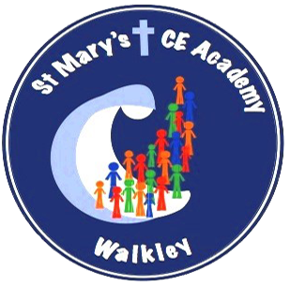

Year 1 Autumn Term 2025
What your child will be learning this term:

Phonics
This term we will be focussing on:
- ea
- ay
- oy
-a-e
- i-e
- o-e
-u-e
-aw
-are (care)
- ir
-ow (snow)
-ew
-ire
-ure
-tion
-tious
-cious

https://schools.ruthmiskin.com/training/view/EQSIEOru/aY1tlIKc



.

Science
Everyday materials
- Name everyday materials.
- Name objects and the materials they are made from.
- Describe properties of materials, how they look and feel.
- Test properties of materials.
- Investigate which material makes the best spacesuit?
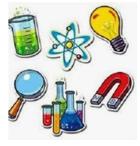
.

Maths
This term we will learn the following:
Place value (within 10)
Counting objects, counting forwards and backwards, one more/one less, comparing and ordering numbers and groups of objects.
Addition and subtraction (within 10)
Number bonds to 10, fact families, addition, adding together, adding more; subtraction, taking away, counting back, finding the difference.
Geometry (shape)
Recognise, name and sort 3D shapes,
Recognise, name and sort 2D shapes, Patterns with 2D and 3D shapes.
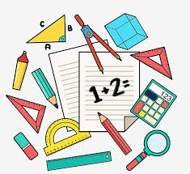

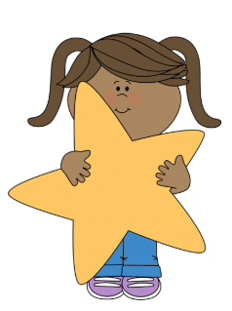

PHSE- Be Yourself
- Think about how we are special.
- Recognise and name common feelings.
- Think about how to manage feelings.
- Think about times that make us feel happy.
- Explain how change and loss make us feel.
- Think about the importance of sharing thoughts and feelings/wellbeing.


RE

What does it mean to belong to a faith community?

What do Christians believe God is like?

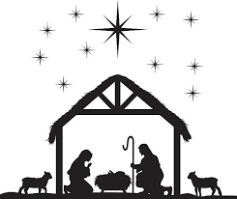
Creative Curriculum

Geography
Continents, oceans, capital cities and the United Kingdom.

History
Chronology: Timeline of dinosaurs.
Study: Why do we remember Mary Anning?

Music
Senses

Art/DT
Painting- drawing
DT- mechanisms



P4C

Philosophy for Children sessions will be taught once a week. The focus of these lessons will change on a weekly basis.

P4C

Philosophy for Children sessions will be taught once a week. The focus of these lessons will change on a weekly basis.


Computing

This term we will be learning how to write and debug algorithms using the software ‘Scratch’.
Computing
Computer systems and networks -technology all around us.

Paint- creating media/digital painting.
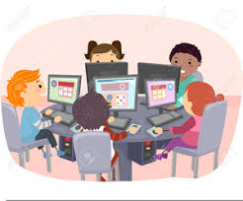

PE

- Fundamental skills

- Team building

