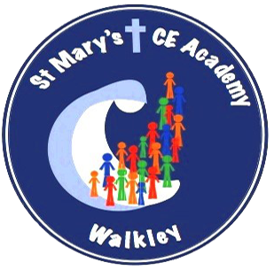
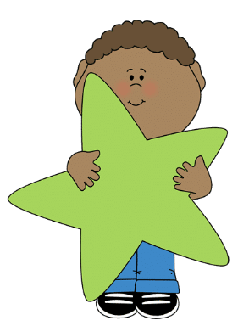
Year 1 Summer Term 2025
What your child will be learning this term:

Writing
Mastery Keys (national curriculum expectations)
- Punctuate sentences using
a capital letter and a full
stop, some question marks
and exclamation marks
- Join words and clauses
using ‘and’
- Some accurate use of the
prefix un-
- Add suffixes where no
change is needed to the
root word e.g. -ed,
-ing, -er, -est

Feature Keys (expectations of the genre)
- Use some story language
- Include and describe new
Characters
- Include and describe the
setting
- Write simple sentences in
sequence (link ideas with
pronouns)
- Include a beginning, middle
and end
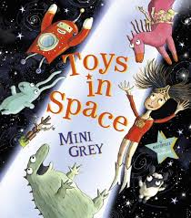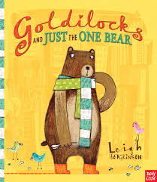

.

Science

Seasons
- What are the four seasons?
- What’s the weather like in Autumn, Spring, Summer and Winter?
- Why does day become night?
- Observe and describe weather associated with the seasons and how day length varies.

Plants, Including Trees
- What are the parts of a plant?
- What are wild plants and where do you find them?
- What are garden plants and where do you find them?
- What makes a tree?
- What types of tree are there?
- What’s the difference between trees?

Maths
- Multiplication and Division
Count in 2s, count in 10s, count in 5s, recognise equal groups, add equal groups, make arrays, make doubles, make equal groups – grouping and make equal groups – sharing.
- Fractions
Recognise half of an object or shape, find a half of an object or shape, recognise a half of a quantity, find a half of a quantity, recognise quarter of an object or shape, find a quarter of an object or shape, recognise a quarter of a quantity, find a quarter of a quantity.
- Position and Direction
Describe turns, describe position – left and right, describe position – forwards and backwards, describe position – above and below and ordinal numbers.
- Place value (within 100)
Count from 50 to 100, tens to 100, partition into tens and ones, the number line to 100, 1 more and 1 less, compare numbers with the same number of tens and compare any two numbers.
- Money
Unitising, recognise coins, recognise notes and count in coins.
- Time
Before and after, days of the week, months of the year, hours, minutes and seconds, tell the time to the hour and tell the time to the half hour.

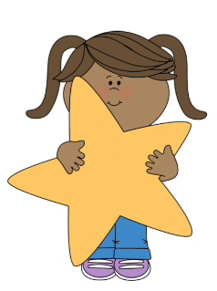

PHSE

- What makes a good friend?
- Should friends tell us what to do?
- What helps me to be happy?
- Where does money come from?
- Where can I keep money safe?
- Why is it important to save money?



RE
Who do Christians say made the world?
Within this unit, pupils will learn about the Christian creation story. They will learn about the key events within the story and be able to retell it using key vocabulary. They will begin to understand that some Christians believe different things about creation. Pupils will begin to compare texts found within the creation story and start to think about how Christians might try to be stewards of the world. Pupils will also consider how Christians may act in response to creation and why they may choose to praise God for it.

Creative Curriculum

Geography

Mapping and fieldwork

History

How have seaside holidays changed over time?

Music

Fantasy and adventure
At the seaside

Art/DT

- Art (3D) - window in the John Bell Chapel at Appleby College designed by Kenojuak Ashevak (2004)

- DT (textiles) – how can two squares of fabric keep you warm?

French
Colours
Numbers to 10



P4C

Philosophy for Children sessions will be taught once a week. The focus of these lessons will change on a weekly basis.

P4C

Philosophy for Children sessions will be taught once a week. The focus of these lessons will change on a weekly basis.

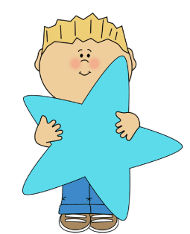
Computing

This term we will be learning how to write and debug algorithms using the software ‘Scratch’.
Computing

Programming A – Moving a robot

Programming B – Programming animations
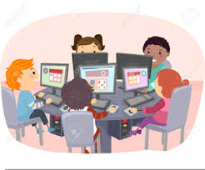

PE

- Athletics

- Striking and Fielding Games

- Ball Skills

- Target Games
