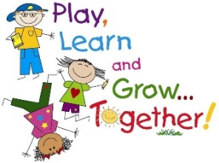
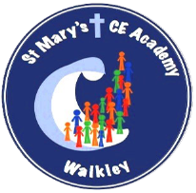
Year 1 Home Learning

Date set: Friday 2ndJanuary
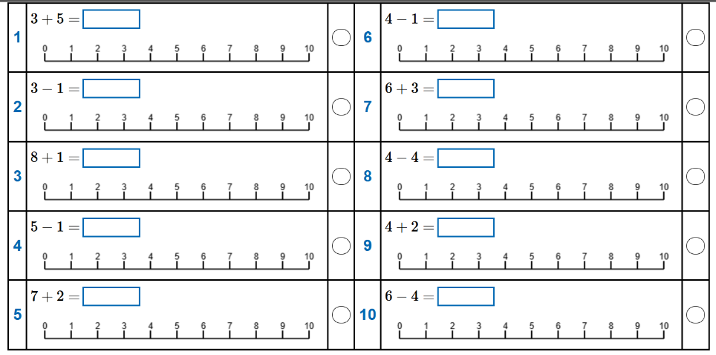
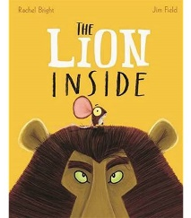
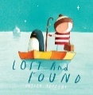
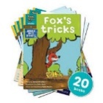
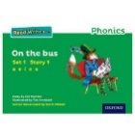
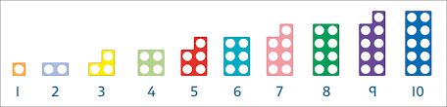
To be returned by: Wednesday 14th January
Spelling
We will now begin spellings tests every half-term. The test will occur on the last week of every half-term. Please practise these in preparation.
- friend
- school
- put
- push
- full
- pull
- house
- our
- to
- do

Please refer to the red words on Dojo to support your child with these.

Reading
Please read with your child every day. Please read using the books from RWI and read to your child using the books sent home. The books sent home are for pleasure and your child should not be reading them. Thank you for your support.

+ +

Phonics
Please read and write.
Orange: ‘She splashed drink on his shirt.’
Yellow: ‘They slept on soft beds with smooth satin sheets.’
Blue: ‘The dog picked up the food and started running away.’
Grey: ‘Sue thought Luke was being rude and didn’t listen.’

Numbots
We have sent login details home for Numbots.
Please help your child to play this game. It is a fun way for your child to learn their Maths and number bonds.
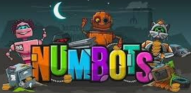

Literacy/SPaG
Can you write two sentences? Can you describe the lion and mouse using simple adjectives. Don’t forget finger spaces, capital letters and full stops.

Please also continue to complete the KIRFS provided on Dojo.

Mathematics

