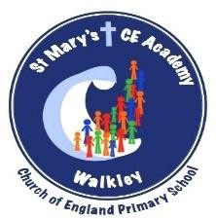
RE Policy

‘Rise above the ordinary’ 2026 onwards

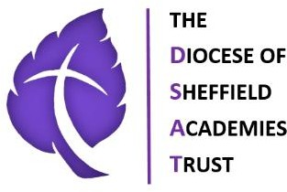

RE Policy

School Vision and Values
Our Vision

We will work as a whole school community to support and deliver a high quality, nurturing and respectful learning environment that inspires all of our children to rise above the ordinary. Our school is committed to being an environment that is open to the spirituality of children.

We will encourage all children to understand and adapt positively as active citizens and courageous advocates – to participate and make a difference in the diverse world in which we live.

Through our high standards of teaching and personalised learning, within a broad and balanced ambitious curriculum, we prepare our learners to make a positive contribution towards society and enjoy future success.

Our Mission “Rise above the Ordinary”

At St. Mary’s we provide a welcoming, safe and happy school where everyone is respected and listened to; a school where we take pride in ourselves and our achievements, enabling children to become confident and successful learners.
We aim to rise above the ordinary and promote excellence by providing a positive, inclusive environment for learning and growth. Inspired by our faith in God, and together, we aim for each child to become the best version of themselves in mind, body and spirit. Our Theological Rationale further encapsulates what we believe in.

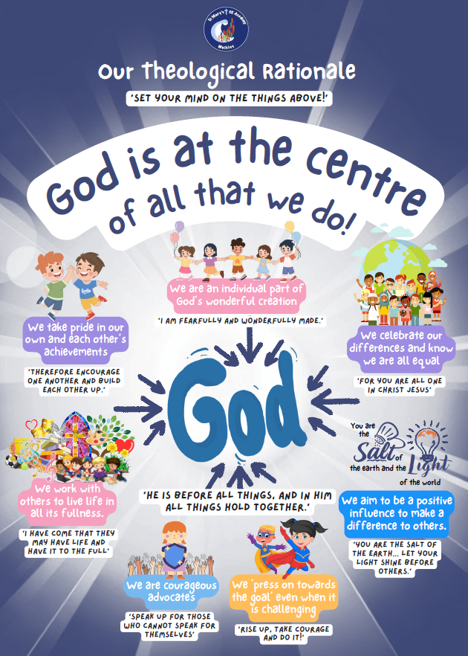

St Mary’s Vision for RE

At St Mary’s, Religious Education is at the heart of our commitment to nurturing spiritually aware, reflective, and compassionate learners. RE provides pupils with the opportunity to explore questions of meaning, purpose, belief, and values, helping them understand themselves, others, and the diverse world in which they live.
Our RE vision is fully aligned with our mission to “Rise above the Ordinary” and is guided by our RISE values – Respect, Inspire, Support, and Exceed:
- Respect: Pupils are encouraged to explore their own beliefs thoughtfully while developing understanding and respect for the diverse faiths, cultures, and perspectives of others.
“So in everything, do to others what you would have them do to you.” (Matthew 7:12)
- Inspire: RE inspires curiosity, awe, and wonder, helping pupils engage deeply with the big questions of life and the teachings of Christianity and other world religions.
“The heavens declare the glory of God; the skies proclaim the work of his hands.” (Psalm 19:1)
- Support: RE nurtures spiritual, moral, social, and cultural development in a safe and inclusive environment, allowing pupils to reflect, ask questions, and express their ideas with confidence.
“Encourage one another and build each other up.” (1 Thessalonians 5:11)
- Exceed: RE challenges pupils to apply their learning thoughtfully and ethically, striving to live out values that promote justice, kindness, and positive contributions to the school and wider community.
“Let your light shine before others, that they may see your good deeds and glorify your Father in heaven.” (Matthew 5:16)
Through RE, pupils develop the five branches of spirituality that underpin our school vision:
- Beliefs for life: Encouraging reflection on their own beliefs (religious or otherwise) and perspectives on life.
Bible reference: “Test everything; hold on to what is good.” (1 Thessalonians 5:21)
- Understanding others: Fostering knowledge of and respect for different faiths, feelings, and values.
Bible reference: “Love your neighbour as yourself.” (Matthew 22:39)
- Joy, wonder, and fascination: Cultivating a sense of enjoyment and awe in learning about themselves, others, and the world around them.
Bible reference: “Shout for joy to the Lord, all the earth.” (Psalm 100:1)
- Imagination and creativity: Using creativity and imagination to explore meaning, ethics, and belief.
Bible reference: “In the beginning God created the heavens and the earth.” (Genesis 1:1)
- Reflectiveness: Developing the ability to thoughtfully reflect on experiences and learning.
Bible reference: “Be still, and know that I am God.” (Psalm 46:10)
At St Mary’s, RE is more than a subject; it is a living expression of our Christian vision, helping children rise above the ordinary by becoming thoughtful, compassionate, and courageous individuals who can make a positive difference in the world.

Aims
At St Mary’s, RE aims to:
- Develop pupils’ spiritual, moral, social, and cultural understanding, in line with our Christian vision and RISE values (Respect, Inspire, Support, Exceed).
- Provide opportunities to explore questions of meaning, purpose, and belief, enabling pupils to reflect on their own values and beliefs.
- Promote understanding and respect for different faiths, worldviews, and cultures.
- Inspire curiosity, awe, and wonder about the world and God’s creation.
- Equip pupils with the knowledge, skills, and vocabulary to think critically and empathetically about religious and ethical issues.
- Prepare pupils to become active, responsible citizens who contribute positively to society.
- Embed RISE values in daily learning, e.g.:
  - Respect: “So in everything, do to others what you would have them do to you.” (Matthew 7:12)
  - Inspire: “The heavens declare the glory of God; the skies proclaim the work of his hands.” (Psalm 19:1)

Belonging
At St Mary’s, we ensure that all pupils feel included, respected, and valued in RE lessons.
- Inclusive teaching: Lessons are designed so pupils of all abilities, backgrounds, and learning needs can access enquiry-based learning.
- SEND and EAL support: Scaffolds, visual resources, pre-teaching, and differentiated tasks ensure all pupils participate meaningfully.
- Collaborative learning: Pupils work together, share ideas, and respect diverse opinions, building a sense of community.
- Developing oracy: Pupils are encouraged to speak confidently about beliefs and values, using sentence stems such as:
  - “I think… because…”
  - “This story shows that…”
  - “I notice that… which makes me think…”
This ensures all voices are heard and pupils can explain ideas clearly and respectfully.
- Celebrating diversity: Learning promotes awareness and respect for multiple faiths, worldviews, and cultural traditions.
Through belonging, pupils gain confidence, feel valued, and understand their place in a diverse community.

Thriving
Pupils thrive in RE when they are challenged, supported, and inspired to explore ideas, ask questions, and reflect deeply.
- Enquiry-based learning: Lessons encourage curiosity, critical thinking, and reflection on religious, ethical, and philosophical questions.
- Reflection and creativity: Pupils use journals, discussion, drama, storytelling, and creative tasks to develop their understanding and express ideas.
- Structured oracy: Pupils are taught to explain, reason, and justify their thinking using sentence stems and discussion frameworks, supporting precise and confident communication.
- Building understanding: Learning is scaffolded with age-appropriate resources, artefacts, visual aids, and ICT to make concepts tangible.
- Progress from starting points: Teachers plan lessons considering prior knowledge, misconceptions, and opportunities for deeper engagement.
- High expectations and resilience: Pupils are encouraged to persevere with challenging questions, reflect on learning, and value mistakes as opportunities for growth.
Through thriving, pupils develop critical thinking, spiritual awareness, empathy, and the skills to engage thoughtfully with the world.

Achieving
Achievement in RE at St Mary’s is measured by the extent to which pupils can apply their learning, communicate effectively, and demonstrate understanding of beliefs and values.
- Assessment for progress: Formative assessment, questioning, discussion, reflection, work scrutiny, and summative assessment at the end of units monitor learning.
- Pupil voice: Children articulate their understanding, reasoning, and reflections confidently.
- Monitoring and evaluation: RE Subject Leader checks curriculum coverage, teaching quality, and pupil outcomes through book scrutiny, lesson observations, learning walks, and discussions.
- Reporting: Parents are informed via annual reports, parent consultations, and celebration in RISE assemblies and collective worship.
- Curriculum impact: Pupils demonstrate knowledge of religions and worldviews, understanding of ethical issues, respect for diversity, and ability to reflect on their own beliefs.
- Living out Christian values: Pupils use their knowledge, skills, and reflections to act responsibly, showing compassion, respect, and active citizenship.
Through achieving, pupils master knowledge, apply skills, communicate ideas effectively, and develop as reflective, thoughtful, and compassionate individuals.

How RE is Taught at St Mary’s
- Curriculum: RE follows the RE Today Curriculum, offering a broad, balanced, and progressive programme for Christianity and other world religions.
- Enquiry-based approach: Lessons encourage questioning, discussion, and reflection.
- Integration: Links are made to PSHE, literacy, history, and the school’s Christian vision.
- Weekly lessons: Timetabled sessions ensure sustained progress, with additional cross-curricular links where appropriate.
- Planning: Medium- and short-term plans ensure progression of knowledge, skills, and understanding, incorporating SEND support and opportunities for challenge.

Resources
- Core resources from RE Today Curriculum: lesson plans, enquiry questions, and supporting materials.
- Supplementary resources:
  - Bibles and age-appropriate religious texts
  - Artefacts and visual aids
  - ICT and multimedia for research and presentations
  - Local visits and visitors from faith communities

Roles and Responsibilities
Headteacher – Overall responsibility for RE provision, standards, and compliance.
RE Subject Leader – Leads curriculum planning, monitoring, staff development, and ensures alignment with statutory and diocesan guidance.
Class Teachers – Deliver high-quality lessons, assess pupil progress, embed Christian and RISE values, and develop pupils’ oracy skills through structured discussion and reflection.

