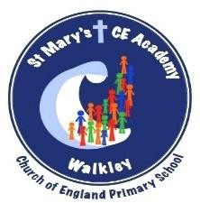
Maths Policy

‘Rise above the ordinary’ 2026 onwards



Maths Policy

School Vision and Values
Our Vision

We will work as a whole school community to support and deliver a high quality, nurturing and respectful learning environment that inspires all of our children to rise above the ordinary. Our school is committed to being an environment that is open to the spirituality of children.

We will encourage all children to understand and adapt positively as active citizens and courageous advocates – to participate and make a difference in the diverse world in which we live.

Through our high standards of teaching and personalised learning, within a broad and balanced ambitious curriculum, we prepare our learners to make a positive contribution towards society and enjoy future success.

Our Mission “Rise above the Ordinary”

At St. Mary’s we provide a welcoming, safe and happy school where everyone is respected and listened to; a school where we take pride in ourselves and our achievements, enabling children to become confident and successful learners.
We aim to rise above the ordinary and promote excellence by providing a positive, inclusive environment for learning and growth. Inspired by our faith in God, and together, we aim for each child to become the best version of themselves in mind, body and spirit. Our Theological Rationale further encapsulates what we believe in.

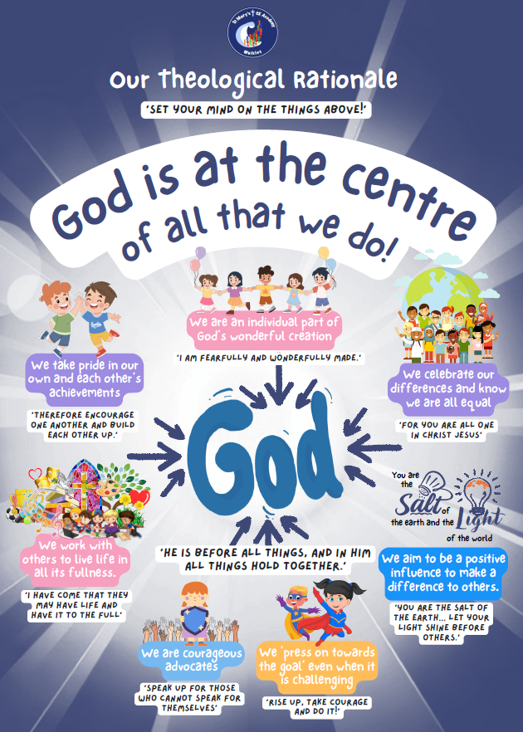

St Mary’s Vision for Mathematics
At St Mary’s, mathematics is understood as part of God’s wonderful creation: ordered, purposeful and rich in pattern and beauty. Every child is a unique individual, made in the image of God (Genesis 1:27), and therefore of infinite worth. Through mathematics, we seek to enable all pupils to flourish, develop confidence, and recognise their potential as learners and contributors to society (Psalm 139:13–16).
Guided by our RISE values – Respect, Inspire, Support and Exceed – and informed by the White Rose Maths approach, our mathematics curriculum is ambitious, inclusive and carefully sequenced so that all pupils, including the most vulnerable, can make strong progress from their starting points.
Our vision for our children:
• Respect mathematics as a universal language that helps them understand and engage with the world God has created, developing enjoyment, curiosity and a sense of wonder (Psalm 104:24–25).
• Be inspired to think deeply, ask questions and reason mathematically, using precise vocabulary and representations to explain their thinking, recognising that God equips them with the ability to learn and grow (Philippians 2:13).
• Be supported to develop resilience and perseverance when solving problems, learning from mistakes within a safe and nurturing environment, and encouraged to work collaboratively so that all can succeed (Philippians 3:14).
• Be challenged to exceed expectations by making meaningful connections within mathematics and across the wider curriculum and real life, building cultural capital and understanding that all knowledge is held together in Christ (Colossians 1:17).
• Develop fluency as a secure foundation for reasoning and problem-solving, enabling them to apply their learning confidently and independently.
As a Christian community, we place high value on relationships, respecting the dignity of every learner and supporting one another through encouragement and collaboration (1 Thessalonians 5:11). Teaching and assessment are used purposefully to identify misconceptions, inform next steps, and ensure that all pupils are given the opportunity to succeed and exceed their own expectations.
Our vision is that every child will leave St Mary’s as a confident, capable and enthusiastic mathematician who uses their God-given gifts responsibly and wisely (1 Peter 4:10), equipped with the knowledge, skills and attitudes needed to contribute positively to society, living as salt and light in the world (Matthew 5:13–16).

Aims
Through the teaching of mathematics, we aim to ensure that all pupils:
- Develop a positive attitude towards mathematics, building confidence, enjoyment, and resilience so they approach challenges with curiosity and perseverance.
- Achieve fluency in number and calculation, enabling recall of key facts and accurate application across a range of contexts.
- Reason mathematically, using precise language, representations, and structures to explain thinking, justify answers, and make generalisations.
- Solve problems effectively, applying mathematical knowledge to unfamiliar situations, real-life contexts, and across the wider curriculum.
- Make meaningful connections within mathematics and beyond, recognising its relevance to everyday life and understanding the world.
- Progress from individual starting points, with high expectations for all pupils, including those with additional needs and those working at greater depth.
- Work collaboratively and respectfully, supporting one another’s learning, valuing different strategies, and developing strong communication skills.
Our teaching is underpinned by the White Rose Maths approach, ensuring learning is structured, inclusive, and builds conceptual understanding before procedural fluency. Assessment is used to identify misconceptions, inform planning, and provide timely support or challenge, so all pupils can succeed and exceed expectations.
Through mathematics, we aim to inspire pupils to use their God-given talents wisely, developing knowledge, skills, and attitudes to contribute positively to society and live out our Christian values as they grow as learners and individuals.

Belonging
At St Mary’s, we believe every child should feel included, valued, and confident in mathematics. Mathematics is taught as a welcoming subject where diversity is celebrated, and all pupils are encouraged to participate fully.
- Inclusive learning: Lessons are designed so pupils of all abilities, backgrounds, and learning needs can access the core curriculum.
- SEND support: Pupils with additional needs are supported through targeted scaffolds, concrete resources, visual supports, pre-teaching, and timely interventions.
- Collaborative environment: Pupils learn to work together respectfully, share strategies, and support each other’s thinking.
- Resources: A wide range of high-quality materials, including concrete apparatus, visual models, working walls, and digital tools, ensure all pupils can engage meaningfully.
Mathematics teaching at St Mary’s promotes equity, confidence, and dignity, ensuring every child feels they belong in the classroom and the wider school community.

Thriving
Pupils thrive in mathematics when they are challenged, supported, and inspired to explore ideas. At St Mary’s, our teaching encourages curiosity, creativity, and perseverance.
- Engagement and enjoyment: Lessons include discussion, questioning, and opportunities for reasoning, fostering enjoyment and resilience.
- Fluency, reasoning, and problem-solving: Daily lessons, fluency sessions, problem-solving sessions, Mastering Number, Times Table practice, and Reflex sessions ensure pupils build confidence and skill.
- Building understanding: Lessons follow a concrete → pictorial → abstract structure, helping pupils grasp concepts deeply before using numbers and symbols.
- Mathematical oracy: Pupils are supported to explain their thinking clearly, justify answers, and discuss strategies using structured STEM sentences (e.g., “I know… because…,” “This works as…,” “I notice that…”). This builds confidence in speaking mathematically and encourages precise, logical reasoning.
- Progress from starting points: Teachers adapt learning to pupils’ prior knowledge and next steps, providing challenge for those working at greater depth.
- High expectations: Pupils are encouraged to take risks, learn from mistakes, and develop a growth mindset.
Through thriving in mathematics, pupils gain the skills, resilience, and confidence to succeed academically and beyond.

Achieving
Achievement in mathematics at St Mary’s is measured not only by academic outcomes but by the extent to which pupils can apply their learning confidently and creatively in school and life.
- Assessment for progress: Formative and summative assessment, pupil voice, quizzes, observations, and termly NTS or end-of-key-stage assessments track understanding and inform planning.
- Monitoring and evaluation: Book scrutiny, lesson visits, pupil discussions, and data analysis ensure high-quality teaching, consistent progression, and identification of strengths and areas for development.
- Reporting: Clear communication with pupils and parents includes ongoing feedback, written reports, and parent consultations.
- Curriculum impact: Pupils demonstrate fluency, reasoning, problem-solving, and retention of key knowledge. They show positive attitudes, make strong progress, and are prepared for future stages of learning.
- Christian values: Pupils are encouraged to use their God-given talents wisely, reflecting on the order, structure, and beauty of mathematics in God’s creation.
Achievement in mathematics means pupils master skills, develop understanding, and are empowered to apply mathematics confidently in real-life contexts.

How Mathematics is Taught at St Mary’s
- Daily lessons with structured progression from EYFS to Year 6, following the National Curriculum, NCETM framework (EYFS), and White Rose Maths (Y1-Y6).
- Three-phase approach: Concrete → Pictorial → Abstract to build deep conceptual understanding.
- Connections within and beyond mathematics: Topics revisit learning and link across subjects, showing relevance to the real world.
- High-quality resources: Counters, base ten, Numicon, fraction tools, visual models, ICT, and digital platforms support all learners.

Roles and Responsibilities
Mathematics Subject Leader
- Strategic leadership, curriculum coverage, progression, monitoring, staff development, and staying up-to-date with national developments.
Class Teachers
- Delivering high-quality lessons, assessing and adapting teaching, providing timely feedback, maintaining high expectations.
Senior Leaders
- Monitoring standards, ensuring statutory compliance, supporting subject leadership, and professional development.

