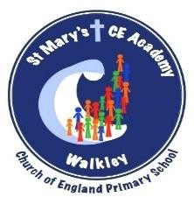
Reading Policy

‘Rise above the ordinary’ 2025 onwards



Reading Policy

School Vision and Values
Our Vision

We will work as a whole school community to support and deliver a high quality, nurturing and respectful learning environment that inspires all of our children to rise above the ordinary. Our school is committed to being an environment that is open to the spirituality of children.

We will encourage all children to understand and adapt positively as active citizens and courageous advocates – to participate and make a difference in the diverse world in which we live.

Through our high standards of teaching and personalised learning, within a broad and balanced ambitious curriculum, we prepare our learners to make a positive contribution towards society and enjoy future success.

Our Mission “Rise above the Ordinary”

At St. Mary’s we provide a welcoming, safe and happy school where everyone is respected and listened to; a school where we take pride in ourselves and our achievements, enabling children to become confident and successful learners.
We aim to rise above the ordinary and promote excellence by providing a positive, inclusive environment for learning and growth. Inspired by our faith in God, and together, we aim for each child to become the best version of themselves in mind, body and spirit. Our Theological Rationale further encapsulates what we believe in.

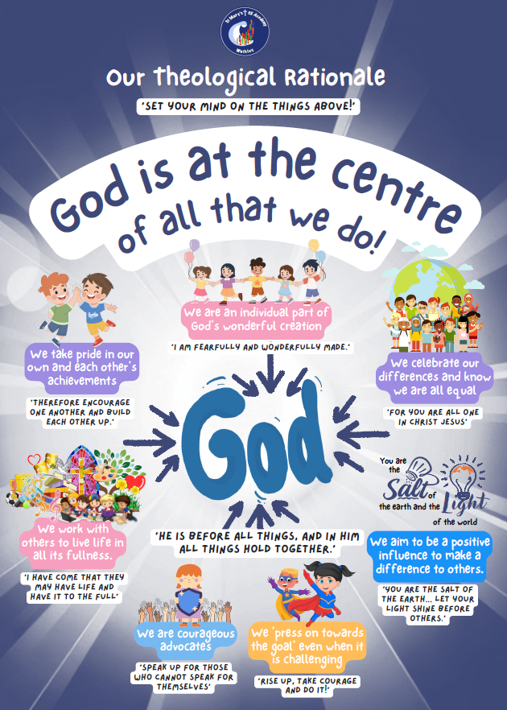

St Mary’s Vision for Reading
At St Mary’s, reading is understood as a powerful, God-given gift that enables understanding, imagination and connection. Through language, we encounter knowledge, develop empathy and deepen our relationship with the world and with God. Scripture reminds us that “In the beginning was the Word” (John 1:1), and as a Christian community, we recognise reading as central to learning, reflection and spiritual growth.
Every child is a unique individual, made in the image of God (Genesis 1:27), and therefore deserving of rich, meaningful opportunities to become a confident and capable reader. Through reading, we aim to nurture curiosity, deepen understanding and enable all pupils to flourish academically, socially and spiritually (Psalm 119:105).
Guided by our RISE values – Respect, Inspire, Support and Exceed – our reading curriculum is ambitious, inclusive and carefully sequenced so that all pupils, including the most vulnerable, make strong progress from their starting points. Reading is taught explicitly and systematically, enabling pupils to develop decoding, fluency, comprehension and a lifelong love of reading.

Our Vision for Our Children
At St Mary’s, we want all pupils to:
Respect reading as a vital life skill and source of enjoyment, recognising reading as a way to explore the world God has created, develop understanding and grow in wisdom (Psalm 19:1–4).
Be inspired to read widely and often, developing a love of books and texts, building imagination, empathy and vocabulary, and recognising that God equips them with the ability to learn, grow and understand (Philippians 2:13).
Be supported to become confident and fluent readers, understanding that reading development takes time and practice, and learning within a safe, nurturing environment where all children are encouraged and valued (Proverbs 16:3).
Be challenged to exceed expectations, developing strong comprehension skills, reading with increasing independence and depth, and applying reading skills across the curriculum and in real-life contexts (Colossians 1:17).
Develop secure decoding and word-reading skills, alongside fluency and expressive reading, so they can focus on meaning and understanding.
As a Christian community, we value relationships and communication, encouraging pupils to reflect, discuss and respond thoughtfully to what they read, using language that builds others up (Ephesians 4:29).
Our vision is that every child will leave St Mary’s as a confident, fluent and thoughtful reader who uses their God-given gifts wisely, equipped with the skills and attitudes needed to engage positively with the world and live as salt and light (Matthew 5:13–16).

Aims
Through the teaching of reading, we aim to ensure that all pupils:
- Develop a love of reading and a positive attitude towards books and texts
- Read fluently and accurately with good understanding
- Develop strong comprehension skills, including inference, deduction and evaluation
- Build a rich and varied vocabulary through exposure to high-quality texts
- Develop secure phonics and decoding skills
- Read widely across fiction, non-fiction and poetry
- Apply reading skills across the wider curriculum
- Make strong progress from individual starting points, with high expectations for all pupils
- Learn to discuss, reflect on and respond to texts respectfully and thoughtfully

Why Is Reading Important?
Reading is essential because it underpins all learning and enables pupils to access the full curriculum. At St Mary’s, reading is valued not only as a core subject, but as a lifelong skill that shapes understanding, character and opportunity.
Reading is important because it:
Develops communication and language skills
Reading exposes pupils to rich vocabulary, sentence structures and ideas, supporting speaking, listening and writing.
Builds imagination, empathy and identity
Through stories and texts, pupils explore different lives, cultures and viewpoints, developing empathy and self-understanding.
Supports learning across the curriculum
Reading enables pupils to access information, understand questions, follow instructions and deepen subject knowledge.
Promotes equality and opportunity
Strong reading skills open doors to future learning, employment and participation in society.
Encourages curiosity and a love of learning
Reading fosters curiosity, independence and enjoyment, inspiring pupils to become lifelong learners.
Reflects God’s gift of language
Within a Christian vision, reading reflects the power of words to teach, inspire and transform, as seen throughout scripture.

How Reading Is Taught at St Mary’s
Reading at St Mary’s is taught through a carefully sequenced and coherent curriculum from EYFS to Year 6, aligned with the National Curriculum.

Early Reading and Phonics
- A systematic, synthetic phonics programme is used from EYFS
- Daily phonics lessons develop decoding and word recognition
- Books are closely matched to pupils’ phonics knowledge
- Early intervention is provided for pupils who need additional support

Developing Fluency and Comprehension
- Regular guided and whole-class reading sessions
- Explicit teaching of reading skills and strategies
- Opportunities for pupils to read aloud with fluency and expression
- Repeated reading and practice to build automaticity

Reading for Pleasure
- Daily opportunities for independent and shared reading
- Class novels and high-quality texts across genres
- Time to talk about books and recommend texts
- Celebration of reading through events and rewards

Teaching and Learning
Teaching of reading at St Mary’s is explicit, engaging and inclusive. Teachers model effective reading strategies, thinking aloud to demonstrate how readers make meaning, infer and evaluate texts.
All pupils access the same core learning, with appropriate support and challenge, including:
- Pre-teaching of vocabulary
- Guided reading and targeted questioning
- Additional challenge for pupils working at greater depth
- Reasonable adjustments and targeted support for pupils with SEND

Resources
A wide range of resources support reading, including:
- Decodable reading books matched to phonics stages
- High-quality class texts and novels
- A well-stocked school library
- Vocabulary displays and reading working walls
- ICT and online reading resources

Assessment: How We Check Progress in Reading
Assessment in reading is ongoing and purposeful, including:
- Phonics assessments
- Teacher observation and questioning
- Reading fluency and comprehension checks
- Pupil discussion and reading journals
- Moderated assessments to support teacher judgement
Assessment information is used to inform planning, intervention and challenge, ensuring strong progress for all pupils.

Monitoring and Review
Reading is monitored regularly through:
- Book scrutiny
- Lesson visits and learning walks
- Pupil voice
- Data analysis and pupil progress meetings
Monitoring is led by the English Subject Leader and senior leaders to inform professional development and school improvement.

Reporting
Progress in reading is shared through:
- Ongoing feedback to pupils
- Termly and annual reports
- Parent consultations

Roles and Responsibilities

English Subject Leader
- Provide strategic leadership for reading
- Ensure curriculum progression and coverage
- Monitor teaching, learning and assessment
- Support staff development

Class Teachers
- Deliver high-quality reading lessons
- Assess progress and adapt teaching
- Promote reading for pleasure
- Maintain high expectations

Senior Leaders
- Monitor standards and outcomes
- Ensure statutory requirements are met
- Support subject leadership

