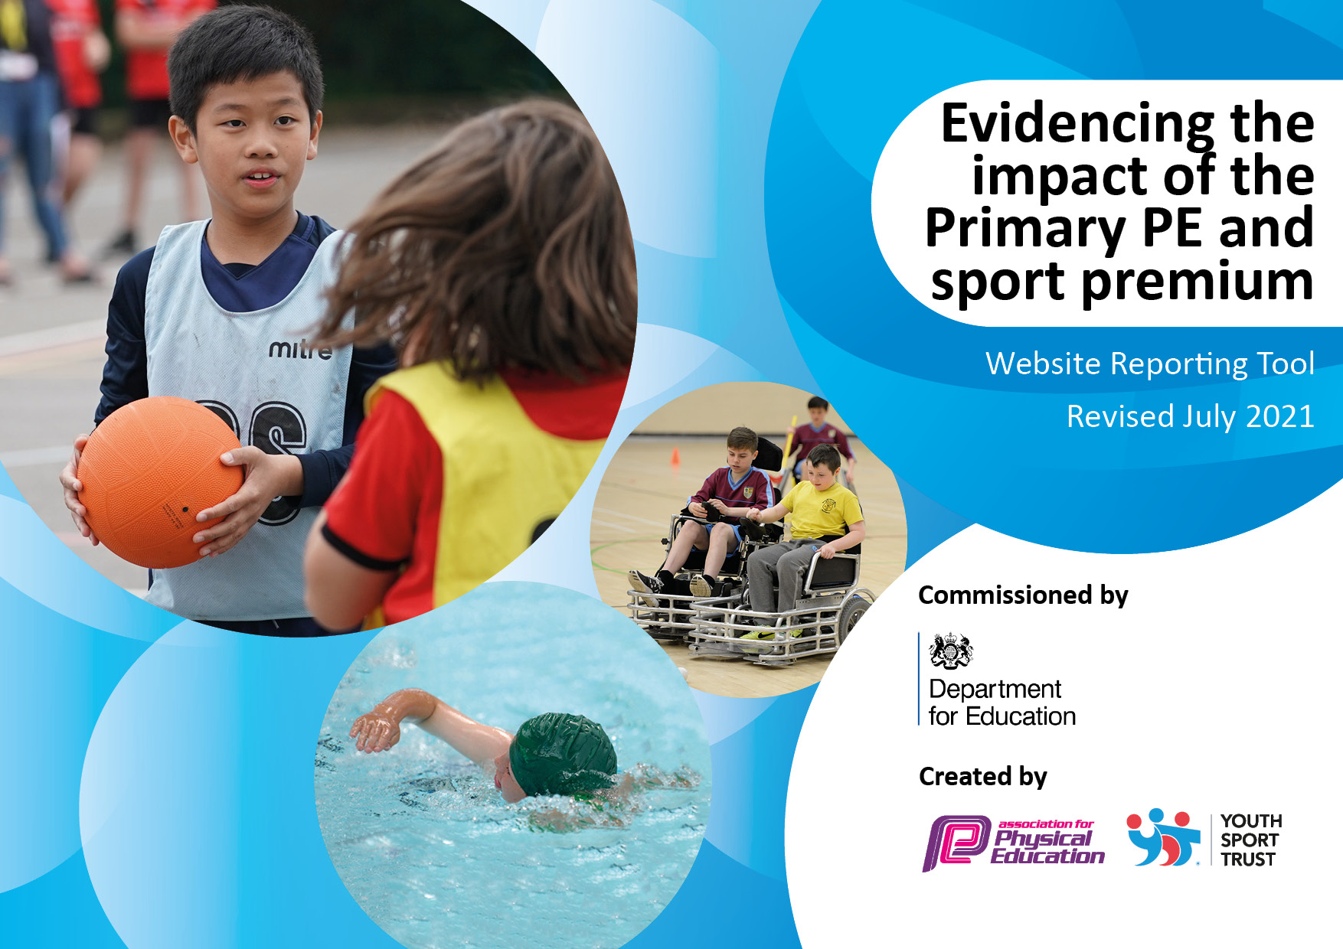

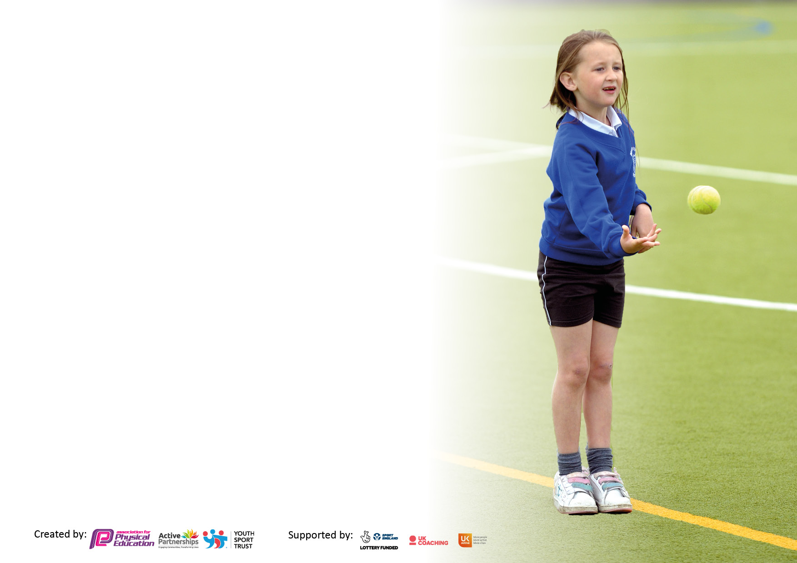

It is important that your grant is used effectively and based on school need. The Education Inspection Framework makes clear there will be a focus on **‘whether leaders and those responsible for governors all understand their respective roles and perform these in a way that enhances the effectiveness of the school’**.

Under the Quality of Education Ofsted inspectors consider:

**Intent** - Curriculum design, coverage and appropriateness

**Implementation** - Curriculum delivery, Teaching (pedagogy) and Assessment

**Impact** - Attainment and progress

To assist schools with common transferable language this template has been developed to utilise the same three headings which should make your plans easily transferable between working documents.

Schools must use the funding to make **additional and sustainable** improvements to the quality of Physical Education, School Sport and Physical Activity (PESSPA) they offer. This means that you should use the Primary PE and sport premium to:

* Develop or add to the PESSPA activities that your school already offer
* Build capacity and capability within the school to ensure that improvements made now will benefit pupils joining the school in future years
* The Primary PE and sport premium should not be used to fund capital spend projects; the school’s budget should fund these.

Pleasevisitgov.ukfortherevisedDfEguidanceincludingthe5keyindicatorsacrosswhichschoolsshoulddemonstrate animprovement.Thisdocumentwillhelpyoutoreviewyourprovisionandtoreportyourspend.DfEencouragesschools to use this template as an effective way of meeting the reporting requirements of the Primary PE and sport premium.

We recommend you start by reflecting on the impact of current provision and reviewing the previous spend.

Schools are required to publish details of how they spend this funding, including any under-spend from 2019/2020, as well as on the impact it has on pupils’ PE and sport participation and attainment. **All funding must be spent by 31st July 2022.**

We recommend regularly updating the table and publishing it on your website throughout the year. This evidences your ongoing self-evaluation of how you are using the funding to secure maximum, sustainable impact. Final copy must be posted on your website by the end of the academic year and no later than the 31st July 2021. To see an example of how to complete the table please click HERE.

Created by: Supported by:

**Details with regard to funding**

Please complete the table below.

|  |  |
| --- | --- |
| Total amount carried over from 2020/21 | £0.00 |
| Total amount allocated for 2021/22 | £17,640 |
| How much (if any) do you intend to carry over from this total fund into 2022/23 | £0.00 |
| Total amount allocated for 2022/23 | £17,640 |
| Total amount of funding for 2022/23. To be spent and reported on by 31st July 2023. | £17,640 |

**Swimming Data**

Please report on your Swimming Data below.

|  |  |
| --- | --- |
| Meeting national curriculum requirements for swimming and water safety.  N.B. Complete this section to your best ability. For example, you might have practised safe self-rescue techniques on dry land which you can then transfer to the pool when school swimming restarts.  **Due to exceptional circumstances priority should be given to ensuring that pupils can perform safe self-rescue even if they do not fully meet the first two requirements of the NC programme of study** |  |
| What percentage of your current Year 6 cohort swim competently, confidently and proficiently over a distance of at least 25 metres?  **N.B.** Even though your pupils may swim in another year please report on their attainment on leaving primary school at the end of the summer term 2021.  Please see note above | 53% |
| What percentage of your current Year 6 cohort use a range of strokes effectively [for example, front crawl, backstroke and breaststroke]?  Please see note above | 50% |
| **What percentage of your current Year 6 cohort perform safe self-rescue in different water-based situations?** | 95% |
| Schools can choose to use the Primary PE and sport premium to provide additional provision for swimming but this must be for activity **over and above** the national curriculum requirements. Have you used it in this way? | Yes/No  Unable to do so 2021-22 due to limited spaces available.  Extra sessions are booked for academic year 2022-23 for the Y6 cohort who missed their swimming sessions due to COVID lockdowns. |

**Action Plan and Budget Tracking**

Capture your intended annual spend against the 5 key indicators. Clarify the success criteria and evidence of impact that you intend to measure to evaluate for pupils today and for the future.

|  |  |  |  |  |
| --- | --- | --- | --- | --- |
| **Academic Year:** 2021/22 | **Total fund allocated:** **£17,640 plus £3394** | **Date Updated: 25.7.22** | |  |
| **Key indicator 1:** The engagement of all pupils in regular physical activity – Chief Medical Officers guidelines recommend that primary school pupils undertake at least 30 minutes of physical activity a day in school | | | | Percentage of total allocation: |
| 81% |
| **Intent** | **Implementation** | | **Impact** |  |
| Your school focus should be clear what you want the pupils to know and be able to do and about  what they need to learn and to  consolidate through practice: | Make sure your actions to achieve are linked to your intentions: | Funding allocated: | Evidence of impact: what do pupils now know and what can they now do? What has changed? | Sustainability and suggested next steps: |
| **To increase the physical activity of all children.**  **To engage more of the disadvantaged pupils in physical activity** | **Timetable of lunchtime clubs to engage both KS1 and KS2 pupils in a broader range of physical activities.**  **Playground climbing equipment installed to increase physical activity levels during breaks & lunchtimes**  **Train the Year 6 students to lead play activities on both KS1 and KS2 yards, to further increase the physical activity of all children.**  **At least 3 nights of physical after school provision, to enable the pupils to engage in an hour of physical activity alongside PE provision and lunch/breaktime activities.**  **Select disadvantaged students to participate in clubs to enhance their physical activity.**  **Target specific pupils who would benefit from more physical activity for their health and well-being.** | **Funds allocated but equipment installation delayed due to manufacturing issues**  **£13,345**  **(part of the Arches Coaching package)**  **£3,764.12**  **(Part of the above funding)** | **Activity and participation levels increased at playtimes. Cross-curricular links. Children have developed their counting/number skills, phonics skills and ability to work as a team.**  **Physical activity of girls increased. Promoted engagement and enjoyment.**  **Physical activity increased. Children have enjoyed playing with a wider range of equipment. Team working skills, collaboration etc increased as a result.**  **Children able to easily access resources. Promoted independence.** | **•Monitor the activities and extra-curricular sporting events that all pupils attend. Use this data to target inactive and vulnerable pupils.**  **•Target inactive/vulnerable children further by creating a ‘Change for Life’ club.**  **Promote healthy eating through assemblies, displays and rewards for healthy options chosen.**  **•Promote healthy eating by running a healthy food club with families.**  **•Promote ‘healthy schools’ week’ by running different activity ‘taster’ sessions.** |
| **Key indicator 2:** The profile of PESSPA being raised across the school as a tool for whole school improvement | | | | Percentage of total allocation: |
| 2% |
| **Intent** | **Implementation** | | **Impact** |  |
| Your school focus should be clear what you want the pupils to know and be able to do and about  what they need to learn and to  consolidate through practice: | Make sure your actions to achieve are linked to your intentions: | Funding allocated: | Evidence of impact: what do pupils now know and what can they now do?  What has changed? | Sustainability and suggested next steps: |
| **All pupils will make good or better progress in PE.**  **Children will be enthusiastic about taking part in PE and sport both within the curriculum and extra-curricular activities.**  **Promote engagement with physical activity by sharing out of school achievements.** | **Purchase of GETSET4PE to help with planning, delivery and assessment of the PE curriculum** | **£550 +VAT** | **Able to lead the subject, teachers become better able to deliver the curriculum with improved confidence.**  **Pupils engaging in more physical activity and more positive children’s experiences.**  **Development of skills through the year groups is better – planned for.**  **Assessment of achievements, skills and knowledge easier to track, using the programmes assessment tools.** | **Develop the assessment tool on Getset4pe to enable teachers to record levels after each teaching unit and to monitor progress.**  **Monitor the physical activity that each pupil in school participates in (questionnaire re. out of school activities/club attendance registers).**  **Develop Sports Council- journalism/pupil voice.**  **Increase lesson drop ins**  **SLT to support lesson observations.** |

|  |  |  |  |  |
| --- | --- | --- | --- | --- |
| **Key indicator 3:** Increased confidence, knowledge and skills of all staff in teaching PE and sport | | | | Percentage of total allocation: |
| 12% |
| **Intent** | **Implementation** | | **Impact** |  |
| Your school focus should be clear | Make sure your actions to | Funding | Evidence of impact: what do | Sustainability and suggested |
| what you want the pupils to know | achieve are linked to your | allocated: | pupils now know and what | next steps: |
| and be able to do and about | intentions: |  | can they now do? What has |  |
| what they need to learn and to |  |  | changed? |  |
| consolidate through practice: |  |  |  |  |
| **Purchase Arches Platinum Package to provide guidance and expertise on Sports Premium funding plus allows participation to Network events for pupils and meetings for Subject Leaders.** | **To provide the PE coordinator with a deeper knowledge of her role.** | **£2,650.00** | **Provided PE leader with a deeper knowledge of her role.**  **Supported with Sports Premium Funding and enabled children to participate in different activities,**  **e.g. dance/ball games and sports leader training.** | **Ensure that all Network meetings/events and CPD is attended.**  **Ensure that knowledge is shared with staff**  **Plan for regular staff meetings to share knowledge** |
| **Key indicator 4:** Broader experience of a range of sports and activities offered to all pupils | | | | Percentage of total allocation: |
| % |
| **Intent** | **Implementation** | | **Impact** |  |
| Your school focus should be clear | Make sure your actions to | Funding | Evidence of impact:  What do pupils now know and what can they do now? | Sustainability and suggested |
| and be able to do and about | intentions: |  | What has changed? |  |
| what they need to learn and to |  |  |  |  |
| consolidate through practice: |  |  |  |  |
| **Additional achievements:**  **Increase the variety of extra-curricular school clubs** | CPD for staff to increase the quality of teaching and learning in gymnastics by team teaching with an experienced coach.  Children can achieve gymnastic badges. | ***£3,764.12 (funded listed as above)*** |  | This is planned for further development in academic year 2022-23. |

|  |  |  |  |  |
| --- | --- | --- | --- | --- |
| **Key indicator 5:** Increased participation in competitive sport | | | | Percentage of total allocation: |
| 3% |
| **Intent** | **Implementation** | | **Impact** |  |
| Your school focus should be clear | Make sure your actions to | Funding | Evidence of impact: what do | Sustainability and suggested |
| what you want the pupils to know | achieve are linked to your | allocated: | pupils now know and what | next steps: |
| and be able to do and about | intentions: |  | can they now do? What has |  |
| what they need to learn and to |  |  | changed? |  |
| consolidate through practice: |  |  |  |  |
| **Increase the number of children participating in competitive sport.** | **To allow all children to take part in a range of competitive sports/competitions.**  **Sheffield Federation for School Sports membership**  **Host Sports Day to ensure all pupils participate in a competitive sports activity this year** | **£625**  **£100** | Two football events participated in in early October 2021 (KS1 and KS2 – promoting girls’ participation in both events).  Competition participation was halted by DSAT at end of October 2021 until Easter 2022, due to COVID – resulting in missing many organised sporting events.    KS2 pupils were able to attend the Inter-school’s sports event  All students engaged, Y6 Play Leaders supported this event, nurturing the younger and more disadvantaged students to facilitate their participation.  Positive feedback from pupils, families and colleagues. | The pupils successfully fielded mixed gender groups to engage in these events.  Ensure that after school clubs are delivered in preparation for these activities next academic year, to enable the students to prepare better prior to the events taking place.  A return to competitive sport increased the pupils’ desire for challenge and to engage in a greater variety of physical activities.  Play leader training requested for earlier on in the school year for 2022-23, to enable them to partner with younger children sooner, getting them more active and engaged with the activities planned for.  This will help with Play/Sports leaders to support after school clubs, the development of Sports Reporting roles, and the play leader’s roles for sports days. |

|  |  |
| --- | --- |
| Signed off by | |
| Executive Head Teacher: | Mrs M Andrews |
| Date: | 25.7.22. |
| Subject Leader: | Mrs E Norris |
| Date: | 25.7.22. |
| Governor: | Mrs A Camm |
| Date: | 25.7.22. |